Harris Student Government · Finance Committee
Fall 2026 HSO Budget Allocation: Methodology, Policy, and Assumptions
Adopted by Committee, Oct 2026

1. Purpose and principles
This document states, in full, the rules, formulas, parameters, and assumptions used to allocate the Fall 2026 quarterly budget across Harris Student Organizations (HSOs). It exists so that any HSO can reconstruct its own allocation from published rules, and so that every discretionary decision by the Finance Committee is recorded with a named rationale. The framework retains the three guiding principles used in prior quarters (Financial Stewardship, Collaboration & Inclusion, and Impact) and replaces per-event 0–100 scoring with club-level scoring on an anchored 1–5 scale.
Nothing in this framework reduces the total budget distributed to HSOs. The policies below change what HSG funds buy, not how much HSG spends.

2. Budget parameters
Parameter | Value | Basis
Total quarterly budget | $20,000 | Set by committee for Fall 2026: the full $20,000 is distributed; no reserve
Flat pool | $5,000 | 25% of the distributable pool, split equally among on-time applicants
Flat share per applicant | $208.33 | $5,000 ÷ 24 applicants; floats with applicant count
Flexible pool | $15,000 | Distributable pool minus flat pool; distributed by formula (§7)
Reserve | $2,000 | None this quarter. When funded, a dedicated line on top of the distributable pool for mid-quarter emergency and flagship requests (§8)
Large-share review threshold | $1,800 | Advisory flag only; no hard per-club cap (§7)
Programmatic food cap | 60% of event budget | §4
Social event ceiling | $400 per event, × co-hosting HSOs | §4
All parameters are editable inputs on the Main tab of the allocation workbook; every downstream number recalculates from them.

3. Roster and eligibility
Twenty-four HSOs are funded applicants this quarter: ACPF, Agora, ALAS, BAPPS, EPSA, HCA, HCC, HEEA, HII, HIVE, HNI, LAM, MASH, MiPPS, MPP, OUTPolitik, PFA, PMPSA, RPD, SASPA, SSC, TAP, UC3P, and WiPP, all scored under the same rules. Three HSOs on the roster did not apply: BEPP, HFG, and HSfP. Non-applicants receive no flat share and no flexible allocation by formula. A late submission received within the 72-hour contest window (§9) is honored in full: it is parsed, classified, and scored under the same rules as on-time applications, with a current rollover balance required at filing. The flat share per applicant recalculates across all accepted applicants, and the late club takes classifications as locked at the end of the same window. Submissions after the window closes receive nothing and apply in the next cycle. Non-applicants' last known rollover balances are recorded for context but are at least one quarter stale; any late applicant must submit a current balance.

4. Food funding policy
Every event in a budget request is classified into one of three categories. Funding treatment follows the category:
Category | Definition | Funding treatment
Cultural / Content | Food or cultural practice is the substance of the programming; the event would be pointless without it (heritage celebrations, cuisine showcases) | Food fully fundable
Programmatic | Substantive content, a speaker, panel, training, service activity, or workshop, that would proceed even with no food | Food fundable up to 60% of the event budget
Social | The gathering itself is the purpose (mixers, socials, bonfires, outings) | HSG contribution capped at $400 per event, multiplied by the number of co-hosting HSOs (§5)
Alcoholic beverages are fundable and count toward food for purposes of these limits. Events serving alcohol must comply with applicable University policies.
Amounts above these limits are excluded from a club's eligible request (§6) before scoring and allocation. Clubs remain free to hold such events using rollover, RSO, or external funds; the policy governs only the HSG subsidy.
Rationale, stated for the record: applications this cycle show a median food share of 77% of event budgets, with eight clubs above 85%. The policy is not anti-food, it distinguishes food-as-mission (fully funded), food-as-logistics (largely funded), and food-as-purpose (funded to a fixed community-building contribution) so that catering does not crowd out speakers, materials, equipment, and programming. The $400 social ceiling is calibrated to observed behavior: the median social event has cost $420–500 in each of the last three quarters with event-level data (Winter 2025, Spring 2025, and the Fall 2026 applications), so the typical social is fully or nearly fully covered and the ceiling binds only on the above-median half. Quarterly averages ($951, $841, $706) sit far above the medians because a small number of high-cost events carry a large share of social spending; the ceiling is deliberately calibrated to the median rather than the average so that outlier spending does not set the benchmark.

5. Co-host stacking
A Social event jointly hosted by k HSOs carries a ceiling of k × $400 for the club fronting the cost. A co-host claim is verified only when the partner HSO lists the same event in its own application or confirms in writing; unverified or "potential" collaborations do not stack. In the Fall 2026 applications, exactly one co-hosted event is cross-confirmed (the MASH–PFA Evening Masters Program mixer, appearing in both applications); all other declared collaborations are recorded but unconfirmed and carry no stacking. External, non-HSO partners do not count toward stacking, as the incentive is directed at collaboration among Harris organizations.

6. Eligible request
A club's eligible request is its stated allocation request minus policy exclusions, prorated where itemized event budgets exceed the HSG ask (because the difference is covered by rollover or external funds):
Eligible request = max(0, Request − Excluded × min(1, Request ÷ Event budget total))
where Excluded is the sum of per-event exclusions under §4–5. The proration ensures a club that itemizes full event costs while requesting only HSG's share is not penalized on money it never asked HSG to pay.
Rollover and external funds are treated as the presumed funder of everything HSG does not cover: excluded amounts and the unfunded remainder of any request are backstopped by the club's own balances pro rata, and how a club deploys its rollover across its events is entirely the club's decision. The committee records each club's total balance for reviewer context (including an informational column on the Events sheet) but never assigns rollover to specific events and never reduces an allocation by netting a balance against it; balances influence funding only through the Stewardship score in §7.2. For Fall 2026, each HSO’s balance is taken from its HarrisHub “Available” balance on October 13, 2026, less any earmarked funds approved under §6.1, so every club is measured the same way and from the same source.

6.1 Rollover and earmarked funds
The committee treats an HSO’s full HarrisHub “Available” balance as rollover that can go toward its events. An HSO can ask to have part of that balance set aside only if the money is restricted by someone outside the HSO:
- External restriction: a sponsor, donor or grant gave the money for a specific purpose or event.
- Prior commitment: a signed contract, deposit or invoice for a specific expense that isn’t yet a pending expense in HarrisHub.
To claim it, list each earmarked amount in the application with its source, the purpose it’s restricted to, and documentation (a sponsor email, agreement or invoice). Approved amounts are left out of rollover when Financial Stewardship is scored.
What doesn’t count: money the HSO plans to save for its own purposes, such as an end-of-year event or a future quarter. Pending expenses already shown in HarrisHub don’t count either, because the “Available” balance already subtracts them.
Earmarked money must be spent on its stated purpose. Any of it still unspent at the next allocation counts as regular rollover.

7. Scoring and allocation

7.1 Scoring
Each committee reviewer assigns each applicant club one integer score from 1 to 5 in each of three bins, Financial Stewardship (weight 0.30), Collaboration & Inclusion (0.25), and Impact (0.45), against the written rubric anchors published on the Main tab of the workbook. A reviewer must score all three bins for a club or none; a blank row is a recusal and is excluded from that club's average. Reviewers recuse from clubs they belong to or have submitted for. Stewardship, and Collaboration are automatically calculated for each reviewer for each club, and overrides are at their discretion.
Each reviewer will score Impact as follows: Impact should be defined by its relevance to the student body, innovation, and policy → subjective. ANY AUTOMATED SCORE MAY BE OVERWRITTEN.

7.2 Objective scorer
Alongside the human reviewers, an automatic scorer computes objective bin scores per club from application data and participates in the committee average with the standing of one reviewer:
- Stewardship from rollover discipline (rollover net of any earmarked funds approved under §6.1; 5 at zero rollover, declining linearly to 1 where rollover equals or exceeds the request; food discipline is enforced by the §4 exclusions and is deliberately not double-counted here): 5 − 4 × (rollover ÷ request)
- Collaboration from verified joint events: 0 events → 1 · 1 event → 3 · 2 events → 4 · 3 or more → 5
- Impact, objective component, from expected attendees (5 at 300 or more, linear below), one voice alongside the human reviewers, who score Impact subjectively per §7.1 (broad relevance to the student body, innovation, and policy orient)
These mappings are fixed and disclosed so every club can verify its own objective scores; with five human reviewers seated, the objective voice carries one-sixth of the committee average.

7.3 Committee score and allocation
Committee Score = mean of the weighted scores of all non-recused reviewers plus the objective scorer. The flexible pool is then distributed in proportion to Committee Score × Eligible Request:
Flexible(i) = [Score(i) × Eligible(i)] ÷ Σ over all applicants of [Score(j) × Eligible(j)] × Flexible pool
Total Allocated = Flat + Flexible, rounded to the nearest $10, and never exceeding Flat + Eligible Request. There is no hard per-club cap; an allocation exceeding the $1,800 review threshold is flagged for committee deliberation rather than mechanically reduced. The design intent: allocation scales with both demonstrated quality and genuine demand, an inflated ask is penalized through the Stewardship score and food exclusions rather than a cliff, and no club's money depends on unverifiable event-level judgments.

7.4 The system at a glance
Figure 1 shows how the quarterly budget divides. Figure 2 traces a single, generic HSO's request through the policy and the allocation formula; the dollar figures are illustrative only.
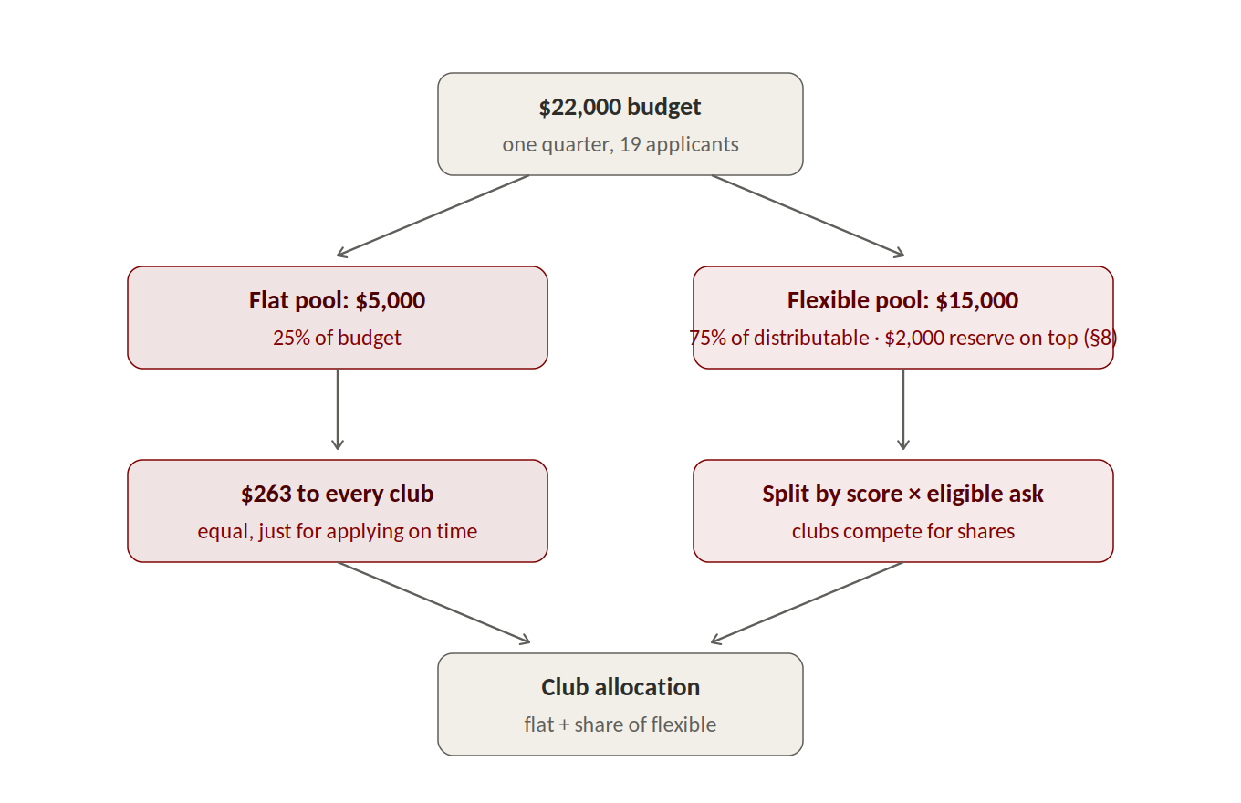
Figure 1: the budget splits once: an equal flat share for every on-time applicant, and a flexible pool the clubs compete for.
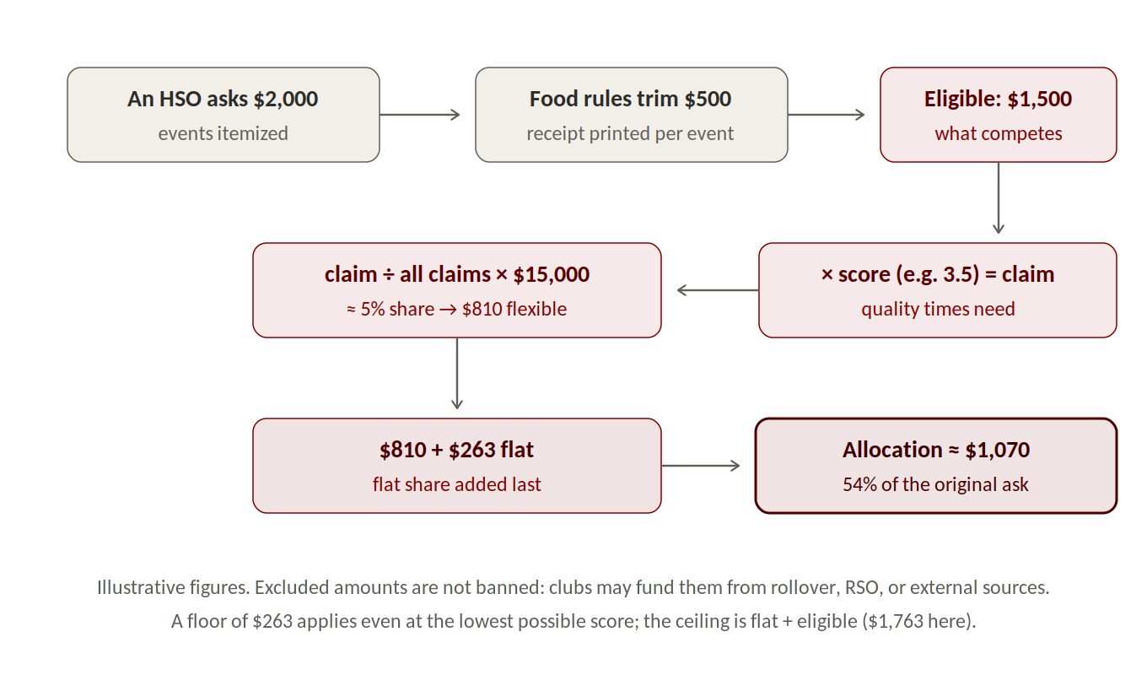
Figure 2: one generic HSO's path, end to end: a $2,000 ask becomes a $1,500 eligible request, earns a ~5% share of the flexible pool at a mid-range score, and lands at roughly $1,070, about 54% of the original ask. All figures illustrative.
Two properties follow from this design and are worth stating plainly. First, policy exclusions act before the competition rather than after it: they reduce what a club competes with, not what it has won, so an excluded dollar typically costs a club well under a dollar of allocation. Second, the flexible pool is proportional and therefore zero-sum: a club's share depends on every other club's claims, so an allocation can fall even when an application improves, if others improved more. This was equally true of the prior event-scoring system; this framework makes it visible.

8. Overrides, reserve, and audit trail
Columns from Flat through Total Allocated in the Results tab are formula-driven and are never overwritten by hand. Committee discretion is exercised in exactly one place: the Committee Nomination column, which is seeded with the formula result and may be overridden only with a written justification in the adjacent column. For Fall 2026 the committee set the reserve to $0, so the full $20,000 is distributed to HSOs. Rounding residue and enforcement recoveries (for example, unitemized request reductions not redistributed under §6 defaults) are still recorded. Any future reserve is funded as a dedicated budget line on top of the distributable pool, so it costs no club any allocation, and is drawn only by application and majority vote. Every draw and credit is recorded in the Reserve Log tab of the allocation workbook at decision time (date, club, amount, purpose, vote, justification, running balance), and the unspent balance is reported at quarter close and rolls into the next quarter budget.

9. Classification protocol
Because the Fall 2026 applications predate this policy, the committee classifies all events this quarter using a published three-question test, applied in order to the club's own event description: (1) is food or cultural practice itself the programming, would the event be pointless without it? If yes, Cultural. (2) Does the event have substantive content that would proceed even with no food? If yes, Programmatic. (3) Otherwise, Social. Where a description is too thin to answer the test, the club is asked to clarify before the committee classifies.
Procedure: the committee classifies blind to dollar impact (the exclusion column is not consulted until all events are classified); each event receives a classifier and a checker, with disagreements resolved by majority vote and a recorded rationale; members recuse from their own clubs' events; the classified list is published to all HSO leads with a 72-hour contest window; contests are resolved by majority vote and recorded whether granted or denied; classifications then lock for the quarter and scoring proceeds. From Winter 2027, clubs self-classify each event at submission and the committee retains reclassification power by majority vote with recorded rationale.

10. Data provenance and corrections
Application data in the workbook was entered from each HSO’s submitted budget form and checked event by event against the source files. Where a form’s layout differed from the template, the committee entered the data by hand and noted the change in the workbook.

11. Transition fairness and amendment
Because these rules are applied to applications written before their adoption, three protections apply this quarter only: the classification contest window in §9; an invitation to clubs to recategorize or restructure their own line items within the same window before classifications lock; and committee discretion, through the §8 override mechanism, to soften any exclusion that operates harshly on an application drafted in good faith under the old rules. The committee will consider a stated glide path (for example, tightening the Programmatic food cap toward 50% by Spring 2027) at the Winter policy review. This document is amended only by committee vote, and each quarter's adopted version is archived with the allocation workbook.
Adopted by vote of the Finance Committee on ______________, 2026. · Chair: Ayan Sarkar · Attachment: Fall 2026 Budget Allocation Framework.xlsx

